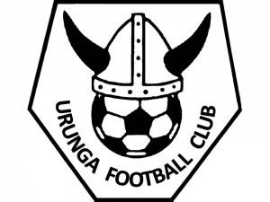 | Urunga Six-A-Side Soccer  Team Nomination Form 2024/25
This summers’ Six-a-Side competition will run on Thursday evenings at the Urunga Recreation Grounds. Season launch will be October 31st and will run until the 19th December. We will break over Christmas and resume games from the 9th January, 2025. Competition will run until the end of February.
Make-up games due to weather etc. may also be scheduled on alternative evenings.

As well as completing a Team Nomination Form, ALL players will be required to register online as an individual. Access to online registration is via the Play Football website www.playfootball.com.au

No player can take to the field unless they have registered online for insurance reasons. Registration options are “Senior/Junior Summer Registration” (can have played for any team in winter 2024 season, does not have to be Urunga FC), or “Senior/Junior Summer Registration (did not play winter)” if the player did not play during the winter season at all.

Cost for Senior Teams: $650 - Youth players pay individually at registration
**If you are a Youth playing only on a senior team, select the pay later option and pay your fee to your Senior team captain**

No teams are to have more than 10 players. All senior registration money is to be deposited into the account below with the *Team Name* as the reference, before 24th October 2024:

Account Name: Urunga Football Club
BSB: 533-000
Account Number: 32860962

TEAM NAME:
 | Preferred Comp (please tick)
Team Captain/Contact: | □ Men’s
Phone Number: | □ Women’s
Email Address: | □ Mixed
 | □ Youth

Dependent on number of teams and skill levels, Divisions within the competitions may be formed

Player Name | Date of Birth | FFA Number
1.
2.
3.
4.
5.
6.
7.
8.
9.
10.

Nomination Forms must be completed and emailed to registrar@urungafootball.com ASAP. Any other questions please contact Jess Snow on 0402 566 394
LIKE & Share the Six-a-Side Facebook page for regular updates.

